BOOK ORDER FORM
The Treasure Hunters Club
To correspond with Mr. McCartney’s upcoming visit to our school, we’re pleased to offer his books. Each book purchased from his order will be autographed by the author and personalized during his visit to our school. This is an excellent opportunity to add to your home library or purchase a gift for friends or family.
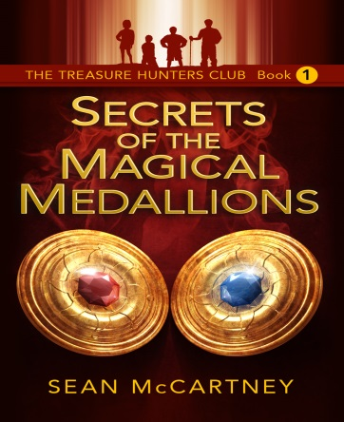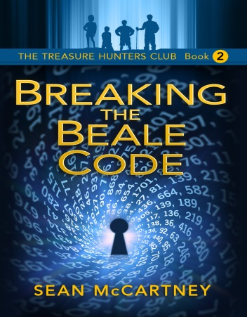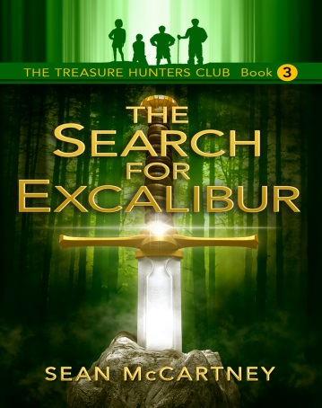

Novel | Retail Price | Discount Price
Secrets of the Magical Medallions | $9.00 | $6.00
Breaking the Beale Code | $9.00 | $6.00
The Search for Excalibur | $11.00 | $8.00

Total # of Books: _______ Total enclosed: $ __________
Please make check payable to: Sean McCartney
Student Name: __________________________________________________________________________________
Class/Grade: ____________________________________________________________________________________

Date: _______ Time: _______ Where: ______
Send home order forms with students. Have them returned and sent to Mr. McCartney to have books prepared.

